

PaymentNet4 - Data Extract Utility
Technology Solution Definition and Non-functional Requirements
Version: 2.2

Prepared By: David Holdren

Copyright ©2008 JPMorgan Chase Treasury Services unpublished. All rights reserved. This document contains proprietary and confidential information of JPMorgan Chase. Reproduction, disclosure, or use of any portion of this document without specific written authorization from JPMorgan is strictly prohibited. This restriction applies to the information on every page of the document. Contents may be disclosed only to authorized JPMorgan Chase employees and consultants for the purpose of performing their job responsibilities.

Table of Contents

1 Introduction 3
2 Solution Overview 3
3 Requirements Analysis 3
4 Solution Components 4
4.1 Master Data Sets 4
4.2 Data Access 4
4.3 Mapforce 5
4.4 Batch Initiation / Prioritization & Scheduler 5
4.5 Mapper Enablement Screen 6
4.6 Mapper Run Screen 6
4.7 Host to Host (H2H) 7
4.8 Monitoring 7
5 Data Mapping Analysis 8
6 Defined Non-functional Requirements 8
7 Non-functional Requirements at risk 8
8 Key Assumptions 8
9 Sign-off and Acceptance of Solution Approach 8

Introduction
This document details the analysis approach for the Data Extract Utility (DEU) Approve 1 Phase.

The analysis consists of the following:
- Technical and Non-Functional requirements discovery
- Solution Architecture Review sessions addressing the following:
  - Requirements Overview
  - Master Data Set
  - Data Access
  - Mapforce Requirement Verification
  - Initiation / Prioritization & Scheduler
  - Mapper Enablement
  - DEU Screens
  - Monitoring
  - Host to Host
- Review of Prototype Activities results

Solution Overview
The solution diagram as defined for the scope of prototype and analysis:
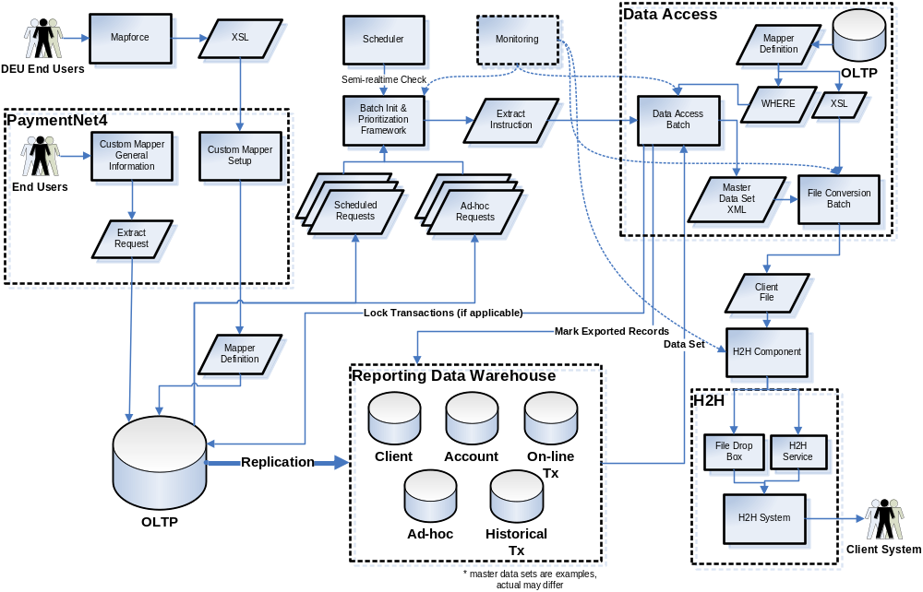

Requirements Analysis
The attached requirements traceability matrix will identify the proposed solutions to met all requirements of the DEU and identify requirements that are not covered in the solution architecture. JPMC will provide guidance on all requirements identified as not being met to give Accenture a disposition to the solution architecture and whether this will be considered in scope for the purpose of estimation of the DEU Solution.

Solution Components
The DEU solution will contain the following technical components for implementation of the system:

Master Data Sets
Master data sets are consolidated views of data, relevant to the PNET4 online system, for the purpose of creating custom mappers with the DEU tool. They define the top level data entities to gather data, and the sub-elements available for selection for custom mapper output.

Prototype Approach
The prototype will create a sample master data set to test the functionality of retrieving data results utilizing XQuery. The data set will be modeled based on the Flex Mapper functionality.

For the purpose of the prototype, there are two configurations of XML views that will be leveraged for testing feasibility and performance:
- Flat Relational Structure - XML view
- Hierarchical structure

Solution Definition
The production master data sets will be created leveraging the results of a data analysis of existing mappers. The purpose of the analysis is to identify the master data sets that will be available to end users of the DEU for creating custom mappers. These data sets will maintain a natural relationship of data (joining sets of data with relations), consistent with the requirements for the DEU.

There are two approaches for conducting this data analysis:
- Supplementary Analysis, to compliment the automated tool analysis, reviewing remaining mappers manually and compiling results
- Automated Tool Analysis, leveraging a data analysis tool to determine consistencies between custom mappers and provide a report indicating the most common elements among mappers
The result of the data analysis will be to create data sets in the database. Data sets will take the form of views in the database.

Data sets will contain the following components:
- View
  - Denormalized, structured XML View
  - Indexes relevant to the view
  - Security applied to data sets consistent with PNET4 approach
  - Maintained by ERWin
- View-based XSD
  - XSDs created from the data sets for use in Mapforce
  - XSDs maintained in Clearcase
  - Schema conforming sample XML data output will be produced for Mapforce Preview (debugging )

Assumptions
The following assumptions apply to the Master Data Sets:
- WHERE clause applied against the master data set based on meta-data stored for the mapper in the database
- Views will be supported during performance testing
- 5 Master Data Sets will be created

Data Access
The Data Access layer will gather metadata from the database and invoke the WHERE clause against the master data set in the database

Prototype Approach
The prototype will cover the following areas regarding the data access approach for retrieving and creating files with XQuery:
- XQuery execution and WHERE clause
  - 3 Approaches to be considered are the following
    - Java injecting WHERE clause into XQuery - Leveraging the Java
    - WHERE cause attached to View, and XQuery
    - Stored proc encapsulation
- Scope of View application via Oracle VPD
- Grouping of records requisite with the export file design (XQuery Prototype)
- Sorting of records requisite with the export file design (XQuery Prototype)
- Locking of hierarchy to prevent concurrent access
  - Approaches to consider:
    - Java (Batch) – Lock the hierarchy explicitly prior to querying the master data set. Unlock when processing is complete.
  - Stored Proc
    - Wrap locking strategy in database via stored procedure
  - Hybrid approach leveraging a combination of the above
- Exception Handling – When failures occur, the ability to unlock any locks placed on the hierarchy
- Marking of records as exported

Based on the results of the XQuery prototype, additional prototyping was performed leveraging XSL as the transformation technology. This is the approved direction for the data access component of the DEU.

Solution Definition
The solution will leverage the following components for data access and transformation to the target output file:
- WHERE clause, based on information obtained in the UI, applied relative to the data set, storing foreign entity keys in a termporary table in the database, filtering the records that will be retrieved for the export file
- Views in the database, representing the data sets to be combined, for joining with the foreign keys retrieved during execution of the WHERE clause
- Processing logic to join the data sets with the temporary table foreign keys, walking each data set per foreign key, resulting in XML consistent with the schema defined for the master data set
- XSL processor component, applying the XSL generated from Mapforce to the XML result, resulting in a structured XML output
- Specification transformation component, transforming (e.g. formatting, padding, justifying) the structured XML output into the target file specification (Flat File, CSV, XML)

The following diagram shows the components of the solution and the required inputs:
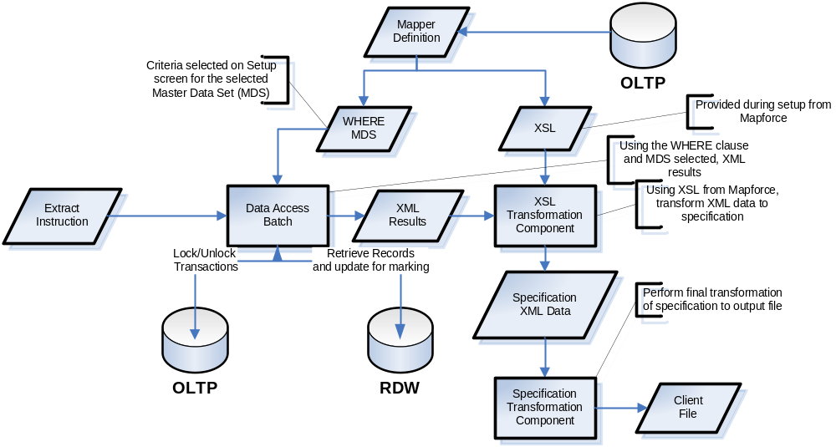
Data access has the following technical requirements:
- Ability to automatically kill XSL transforms running longer than a configurable duration
- Support for locking at the transaction level for mappers
- Support for marking of transaction records in the OLTP & RDW

Assumptions
The following assumptions apply to the Data Access Component:
- The approach for data access and custom mapper definition will be leveraged for executing Flex Mappers
- Mapper definition will be correlated with a mapper id
- Approach leverages chunking, if feasible

Mapforce
Mapforce is a data mapping tool that is responsible for the creation of the XSL component of the solution architecture. The tool is meant to provide a reasonable means of producing the target output file for the custom mapper, based on the master data set selected during design of the mapper.

Prototype Approach
Leveraging Mapforce, create the XQuery to retrieve records from the database, and process them into file for persistence by a Spring Batch job. Document any gaps in meeting requirements.

Solution Definition
Mapforce will be the mapper design tool for the DEU. As master data sets are identified, a source XSD schema will be provided to developers (TC’s) utilizing Mapforce. These will be leveraged in conjunction with a template XML schema definition providing the structure to layout the target export file. The designer will link fields in the master data view to elements in the schema, which defines the meta-data for each field, as well as header, footer and other elements.

In addition, a document in support of using the Mapforce tool will be created to aid Technical Consultants.

Assumptions
- Mapforce produced XSL is the only input that defines the structure of the mapper.
- Mapforce audience will be Technical Consultants
- Custom functions will be created, if needed, to meet the requirements of the DEU

Batch Initiation / Prioritization & Scheduler
The Batch Initiation and Prioritization component manages the number of concurrently running batch jobs, and the order in which to consider subsequent requests for mappers to run. The scheduler component will frequently invoke the batch job for initiation and prioritization.

Prototype Approach
There is no prototype for this component.

Solution Definition
The initiation solution is responsible for invoking batches consistent with the rules for throttling and priority.
The Prioritization batch has the following solution components:
- Initiation Batch Job wrapper, frequently running to determine if there are jobs of a specific type that require initiation (e.g. custom mappers)
- Prioritization component to determine prioritization of queued jobs
  - Evaluates schedule of batch jobs pending of a single job type to select the next one to run, based on a predefined set of rules. The criteria defined so far is the following:
    - Priority (Ad-hoc or Scheduled)
    - Organization / Hierarchy (1 concurrent per organization)
  - Limit of maximum number of concurrent batch executions for a given batch module (e.g. custom mappers) with a runtime variable (configuration default), stored in the database

The Prioritization Batch has the following technical requirements:
- Ability to initiate a configurable type of job (e.g. custom mappers OR flex mappers)
- Ability to update the prioritization batch to prevent additional jobs from starting
- Ability to limit the maximum number of concurrently running jobs managed by the framework
- DB-based schedule of batch jobs to run (also see Monitoring)
- DB-based queue of batch jobs pending to run (also see Monitoring), containing priority
- DB-based flag indicating whether jobs can be running (to support outage windows)
- DB-based repository of running and completed batch jobs (this is provided by Spring Batch)

Invocation of the Prioritization batch will be handled by Control-M, accounting for dependencies for the type of job being initiated with the prioritization batch.

Assumptions
- Prioritization scoring is performed only with information in the job schedule table.
- Restart of running jobs is not supported
- Prioritization/Initiation can be leveraged for Imports and Exports batches

Mapper Enablement Screen
The Mapper Enablement Screen allows for the creation of custom mappers in the DEU. The screen is responsible for the upload of XSL from Mapforce, and setting the criteria/hierarchy for the mapper to run. The screen also controls whether the mapper is client-enabled.

Prototype Approach
There is no prototype for this component.

Solution Definition

The Mapper Enablement screen is responsible for providing a means to set up a mapper and control client access to the mapper in the PNET4 system.

The screen will allow the following functions:
- Upload of XSL output from Mapforce
- Selection of criteria to narrow the results of the mapper
- Selection of hierarchy to narrow the results of the mapper
- Preview the output of the mapper with limited data rows (e.g. rowcount)

The following technical requirements exist regarding the storage of the information captured on the Mapper Enablement Screen:
- Storage in the database of an aggregated WHERE clause, consistent with the implementation strategy for applying filtering criteria with Mapforce and XSL
- Storage of the master data set in use for calling the data access component
- Field listing for criteria selection will be determined based on the master data set in use, and will contain a subset of all fields available stored as meta-data in the database
- Meta-data captured linked to a central identifier in the database

Assumptions
- Mapper meta-data will be correlated with a mapper id
- Process of creating mappers will vet performance concerns outside of the DEU
- Custom Mapper Setup screen is enabled via PNET4 entitlements

Mapper Run Screen
The Mapper Run screen is simply the Custom Mapper Screen. There is no change to the design of the screen.

Prototype Approach
There is no prototype for this component.

Solution Definition
As defined in the Custom Mapper PSD (Mapper FRD) as part of the DEU Business Requirements stream, the screen will capture the run characteristics of the custom mapper (e.g. daily, weekly, cycle, etc), whether transactions are exported and the name of the mapper.

Assumptions
- Custom Mapper Run screen is enabled via PNET4 entitlements

Host to Host (H2H)
Host to host is a JPMC provided service for secure transmission and receiving of files to/from clients. The service leverages a messaging infrastructure to notify the PNET4 and H2H when files are ready for processing by the various sending or processing services.

Prototype Approach
There is no prototype for this component.

Solution Definition
The DEU will leverage host to host services for the outbound transmission of custom mapper export files. The process for invoking host to host services for transmitting files is the following:
- Store file for transmission in dedicated Host to Host directory on file server
- Call JMS H2H service to indicate file is ready for transmission
- Process status update response from H2H, indicating file transmission was successful

Assumptions
- Host to Host services will provision clients for utilizing the service
- Host to Host services will maintain client information regarding file transmission
- Host to Host will store outbound files for a nominal duration, and perform ‘resend’ functionality
- Production Support groups will manually perform resends outside the period where host to host maintains the file
- Parameters required for H2H messages exist within the PNET4 system, and no additional screens are required

Monitoring
The monitoring components provides visibility into the runtime characteristics of the batch processes around the schedule of mappers running, those pending a run and statistics related to mapper execution.

Prototype Approach
There is no prototype for this component of the solution.

Solution Definition
The monitoring solution will contain the following components:
- JMX bean to perform the following:
  - Show currently running batch jobs for DEU
  - Show pending job requests (see Initiation/Prioritization)
  - Show Job Information, including job meta-data and setup info
  - Show Job Statistics (e.g. run times, return code, etc)
  - Update database to prevent additional jobs from starting

The monitoring of DEU will also have the following technical requirements:
- Ability to prevent additional jobs running
- Ability to view the status of all running jobs
- Ability to view pending job requests
- Ability to view job statistics (e.g. run times, final status, etc)
- H2H Monitoring of service methods via Wily
The monitoring of DEU will have the following external technical requirements (not in scope for DEU):
- H2H Monitoring met by external service
  - Know if service consuming status messages is up
  - Queue depth
  - Retry counts for file send
  - Space for available downloads
  - Avg Transmission time
  - SLA's hit/missed

Assumptions
- JMX can meet the above requirements for providing a view of the information
- Throttling and flag meta-data will be stored in the database and could be updated via JMX. The console may be enabled by Weblogic or a custom screen.

Custom Mapper Interface
The implementation of the DEU will include a generic interface for executing mappers, designed during the detailed design phase. The DEU Data Access Framework will be the first implementation of that interface. The interface can be leveraged for the creation of mappers in java code.

Data Mapping Analysis

Tool analysis to be run to identify targets for master data sets. Results are TBD.

Defined Non-functional Requirements
The following are the defined non-functional requirements for the Data Extract Utility:
- Approach defined for custom mappers will be leveraged for Flex Mappers
- The client hierarchy specified for a mapper must be locked when the hierarchy is in use by custom mappers
- DEU cannot run while Loader job is running
- The DEU must allow visibility to the status/lifecycle of file transfer via monitoring
- Ability to turn off initiation for batch jobs, for instance during off-line windows, deployments, etc
- Host to host (H2H) is the selected transmission service for client file communication
- H2H must handle standard formats such as EDI

Non-functional Requirements at risk
The following non-functional requirements are at risk of being able to be met by the technical solution for the DEU:
- To be identified during detailed design phase.

Key Assumptions
- There are no SLA’s for custom mapper completion time.
- Technology solution is feasible for use to execute Flex mappers.

Appendix - Requirement Mapping

The following requirements mappings were created during the analysis period:

